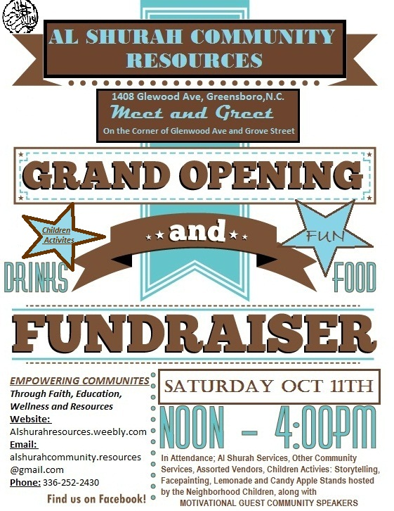
AL SHURAH COMMUNITY RESOURCES
1408 Glenwood Ave, Greensboro, NC

FOR IMMEDIATE RELEASE

AL SHURAH COMMUNITY RESOURCES
“GRAND OPENING AND FUNDRASISER”

GREENSBORO, NC -20TH September, 2014 -Al Shurah Community Resources will be launching its Grand Opening and Fundraiser to the Glenwood Community on Saturday, October 11th 2014 starting at noon to 4 pm. This event will be promoting all the services that will be provided at the new location; located at 1408 Glenwood Ave, Greensboro, NC 27403. These services consist of a “Referral and Resources Service” which includes self improving workshops, “Health and Nutrition Services”, which includes our food pantry and community garden and “Educational Services” which includes our GED Prep Program. We decided to use this opportunity while raising awareness of our organization to the Glenwood Community and surrounding areas; to also fundraise to help generate capital for our programs.
Al Shurah Community Resources received it first major contract with Greensboro Housing Authority to do a test case GED Prep Program this fall at Ray Warren Housing with selective participants. We are very excited about this opportunity to help the residence get a chance to receive their GED along with preparing them for career goals through our Work Readiness Program.

This event will have tables set up about the services we offer, along with other community services such as Health Awareness (Sickle cell, Aids, High Blood Pressure), Educational Information, Crime Awareness, Self Awareness, etc. We will also have a children’s section which will consist of a Lemonade stand and Candy Apple stand that will be operated by the local children, tent for “Story Telling”, face painting and some games. There will be a 50/50 raffle (funds raised at this event will go directly towards the food pantry, GED prep program, and self improvement workshops). We also invited many different vendors along with motivational speakers discussing education, health and unity.

About: Al Shurah Community Resources was created on April 4th 2014, with the intention of helping the community around us to obtain sustainability through education, work readiness, proper eating habits, etc. We consider ourselves to be very involved in our community by being visible during community functions , community meeting and by initiating different key programs and events that will in able the residences opportunities to obtain sustainability.

FOR MORE INFORMATION:
Khadijah Bethea- Representative of Public Relations
Phone: 336-252-2430
Email: alshurahcommunity.resources@gmail.com
www.alshurharesources.weebly.com
###

Mission Statement
Al Shurah Community Resources is a faith base non-profit organization committed to enhancing the quality of life by creating opportunities of sustainability in our community through education, family services, community programs, and partnerships with other organizations.
What is the event on Saturday all about?
This event is aimed at getting the information out about the services offered by Al Shurah Community Resources. The strength of the program draws directly from the number of people successfully utilizing our services. One of the main focuses of Al Shurah Community Resources is self sustainability. Since our initial presence in the community we have had an opportunity to participate in a few events sponsored by the Greensboro Housing Authority. These events where geared toward helping residence with resources to assist them with acquiring self sustainability.
What can people expect at this event?
Food and drinks will be provided by local vendors, along with activities for the children which will include; storytelling, face painting, and other activities. There will be a 50/50 raffle (funds raised at this event will go directly towards the food pantry, GED prep program, and self improvement workshops).
How did Al Shurah Community Resources come about and what role does it serve in the community?
The idea for the Al Shurah Community Resources nonprofit company came from the principles, after seeing a need in the overall community to help residents achieve sustainability. Al Shurah will commit to facilitating these steps towards self sustainability through health, nutrition education, educational improvement, self developing workshops and additional resources. Our first major project is the GED Prep Program partnership with Greensboro Housing Authority; which started on September 15th 2014. The Grand Opening of all our services will be October 11th, 2014 from noon to 4:00pm.
Al Shurah Community Resources Hours of Operations
We decided to best serve the community; our hours of operation will be Monday thru Thursday from 9:00am to 5:00pm and on Fridays 9:00am to 12:00pm. Weekends the office will be closed. Al Shurah Community Resources also wants to get involved and participate in neighborhood projects. We’d love to hear ideas from people for potential projects, and what we can do to better our community.

